Private & Commercial Pilot ASES Oral
Add-on to ASEL

- PREFLIGHT PREPARATION
.

Task F: Performance and Limitations (ASEL and ASES)

References: FAA-H-8083-1, FAA-H-8083-25; AC 61-84; POH/AFM.

Objective: To determine that the applicant:

- Exhibits satisfactory knowledge of the elements related to performance and limitations by explaining the use of charts, tables, and data to determine performance and the adverse effects of exceeding limitations.

2. Computes weight and balance. Determines the computed weight and center of gravity are within the airplane’s operating limitations and if the weight and center of gravity will remain within limits during all phases of flight.

3. Demonstrates use of the appropriate manufacturer’s performance charts, tables, and data.

4. Describes the effects of atmospheric conditions on the airplane’s performance.

=================================================

- What do you have to do to stay current in a seaplane?

- When do you need a complex endorsement?

- Can you jump into a seaplane with straight floats that has flaps and a constant speed prop?
  - Not unless you have a complex endorsement.

- You’re flying a seaplane with cowl flaps, when would you close them?
  - Probably never due to engine heating, however, your CHT will tell you.
  - Takeoff should always be done with cowl flaps open to prevent damage due to high CHT’s.

- If you fly amphibs and you do three takeoffs and landings at an airport, are you current to carry passengers and land on water?
  - No. The plane is configured for land and considered a land plane when landing on land.

- What if you do two takeoffs and landings on a lake then come back to the airport, are you current to carry passengers and land on water?
  - No. Need three takeoffs and landing on water.

- What is the model number of the floats?
  - What would “2550” mean?
    - can support 2550#

- What are the FAA Rags regarding float requirements?
  - Each float must have at least 4 water tight compartments
  - Each float must support 90% of gross weight (total of 180%)
  - Must be able to support the aircraft with two compartments flooded

- What minimum water depth is needed for these floats?
  - Minimum 18” with 24” preferable.

- Where do we fall on the W&B chart with one passenger of 190lbs?

- What is a characteristic of a forward CG in a seaplane?
  - More dangerous for landing

- What is a characteristic of an aft CG in a seaplane?
  - Might not be able to get up on step

- In the air, how can you determine the length of a lake?
  - At 90kts, you should travel about 1.5 miles every minute

- How do you know if you can take off on a lake?
  - Past experience
  - Winds, glassy water, surrounding area obstacles, et al
  - Use the seconds method on downwind.

- What size lake do you feel comfortable landing in?

- What extra items could you carry that aren’t on a land plane?
  - PFD
  - Oar or paddle
  - Bilge
  - Ropes
  - Plastic containers for billfold, cellphone, etc.

- If you’re landing too far (landing long), how do you slow the plane down?
  - Push yoke forward once you’ve slowed down enough not to tip over.

- When would you keep the rudder pedals down when taking off?
  - In a crosswind.
  - Once in plow stage, pull them up.

- Is there an arm or weight restriction when adding weight to the floats?
  - Should be placarded or in POH.

Task G: Operation of Systems (ASEL and ASES)

References: FAA-H-8083-23, FAA-H-8083-25; POH/AFM.

Objective: To determine that the applicant exhibits satisfactory knowledge of the elements related to the operation of systems on the airplane provided for the flight test by explaining at least three of the following systems:
1. | Primary flight controls and trim.
2. | Flaps, leading edge devices, and spoilers.
3. | Water rudders (ASES).
4. | Powerplant and propeller.
5. | Landing gear.
6. | Fuel, oil, and hydraulic.
7. | Electrical.
8. | Avionics.
9. | Pitot-static, vacuum/pressure and associated flight instruments
 | instruments.
10. Environmental.
11. Deicing and anti-icing.
==================================================

- What is the rated horsepower of the engine?

- What type prop does it have?

- What type of fuel does it use?

- Can you use auto gas in this aircraft?
  - Only if STC’d or an emergency

- Why do some planes have two sides on the oil dipstick?
  - Example: Tailwheel land plane – aft low; converted to seaplane level

- What is the purpose of the step?
  - To minimize float drag

- When you inspect the floats, what are you looking for?
  - Loose cross bars, broken stringers, wires off pulleys, holes/dents in floats, water in floats, debris on wires

- How much does fuel weigh?
  - 6# / gallon

- How much does water weigh?
  - 8# / gallon

- Why is this important to know?

- Why is water splashing on a prop harder than flying through rain?
  - Larger drops of water.
    - 1000x worse
  - Rain drops can’t slap the prop like lake water.

- If you have a leaky compartment, which one would it usually be?
  - Usually the step
    - takes the most beating
    - baggage compartment is there.

Task H: Water and Seaplane Characteristics (ASES)

Reference: FAA-H-8083-23.

Objective: To determine that the applicant exhibits satisfactory knowledge of the elements related to water and seaplane characteristics by explaining:

1. The characteristics of a water surface as affected by features, such as:
  - size and location
  - protected and unprotected areas
  - surface wind
  - direction and strength of water current
  - floating and partially submerged debris
  - sandbars, islands, and shoals
  - vessel traffic and wakes
  - other features peculiar to the area
.
- Float and hull construction and their effect on seaplane performance.

- Causes of porpoising and skipping, and the pilot action required to prevent or correct these occurrences.

============================================

- The airplane’s tendency to stay pointed into the wind on the water is called?
  - Weathervaning

- What causes skipping?
  - Coming in too fast on a low approach

- What causes porpoising?
  - Too little or too high of an angle of attack
  - Improper CG

- If you have an out of control porpoise, what do you do?
  - Pull back on the yoke
  - Cut power to idle if severe

- What’s the easiest way to turn into the wind?
  - Pull water rudders up and weather vane

- What are some indicators of wind direction?
  - Wind streaks, flags, smoke, nearby AWOS, waves, smooth or rough shoreline, moored boats, plane weathervanes

- What are some indications of wind speed?
  - Wind streaks, white caps

- When do wind streaks generally occur?
  - 6-8 knots

- When do white caps generally occur?
  - 12-15 knots

- What would be termed “the protected side of the lake”?
  - Where the water near the shore is smooth.

- If a storm is coming, what would you do?
  - Be on the upwind side.
  - Open water sailing or idling
  - Get out of dodge.

- What is the problem with glassy water
  - When taking off?
    - Friction. Dropping back into the lake due to depth perception.
  - When landing?
    - Friction, depth perception

- When making a glassy water landing, when do we pitch up?
  - Land close to the shoreline, use shore, docks, etc.
  - Pitch up when over your last shoreline
  - 65kts

- How do you land on glassy water following an engine failure?
  - Near the shore and maintain a slightly higher than normal pitch attitude

- If you have an engine failure, would you use flaps or not?
  - No flaps

- Can you take off and land at night?
  - Part 91, yes.
  - However, the FAA could get you for reckless and careless operation.

- What would be a maximum wave height to make a landing?
  - About a foot. Anything more is hard on the plane.

- What sort of issues are there with a crosswind landing?
  - Landing crooked
  - Capsizing

- What issues do you have with swells?
  - Can’t tell depth of wave heights
  - Landing crosswind
  - Capsizing

Task I: Seaplane Bases, Maritime Rules, and Aids to
Marine Navigation (ASES)

References: FAA-H-8083-23; AIM; USCG Navigation Rules, International−Inland; POH/AFM; AFD.

Objective: To determine that the applicant exhibits satisfactory knowledge of the elements related to seaplane bases, maritime rules, and aids to marine navigation by explaining:

1. How to locate and identify seaplane bases on charts or in directories.
2. Operating restrictions at various bases.
3. Right-of-way, steering, and sailing rules pertinent to seaplane operation.
4. Marine navigation aids, such as buoys, beacons, lights, and sound signals.

===============================================

- How does a seaplane base appear on a sectional/WAC chart?
  - An anchor

- Other than on sectionals, where else can you find seaplane bases?
  - SPA directory, State websites

- What color(s) is the beacon at a public seaplane base?
  - Yellow and white

- Can you land on any lake or river?
  - No

- How can you find out if a body of water is open to seaplane operations?
  - Sherriff, SPA Directory, DNR or State websites

- How do you know if there are any ordinances for a lake?
  - SPA Directory
  - State website (may not be all inclusive)
  - Local authorities (have jurisdiction)
  - Sheriff
  - Army Corps of Engineers

- Can you dock where there are the dots around an island?
  - No. It is a wildlife refuge

- How would you refuel at remote locations?
  - Can use auto gas in an emergency, carry fuel bladders

- Rivers:
  - What should you be careful about when flying along rivers?
    - Power lines crossing the river
    - Barges
    - Bridges

  - What should you be careful when landing or taking off on a river?
    - Current & wind
    - Logs
    - Stumps
    - Sandbars
    - Rocks
    - Riverboat traffic
    - Power lines crossing overhead

  - How do you know which way the current is flowing? Name some indicators.
    - Watch for debris flowing
    - Sandbars downstream of rocks
    - Boats moving faster going downstream
    - Waves (rapids) from obstructions

  - Do you land with or against the current
    - With the current if it is less than the wind speed.
  - Do you takeoff with or against the current
    - With the current if it is less than the wind speed.
  - Which takes precedent? Wind or Current?
    - Wind or whichever is higher speed
- Reservoirs:
  - What are some concerns when landing in reservoirs?
    - They are man made
    - Stumps
    - Pilings
    - Getting permission from Army Corps of Engineers

  - Where is the best place to land in a reservoir?
    - Between marina buoys
    - In the center

- What are some indicators of shallow water?
  - Sandbars, rocks, rapids, logs, colors change, wing dams in a river.

- What are some hazards when landing or taking off in the early spring?
  - Unforeseen ice
  - Remnants of logs and branches
  - Hypothermia

- Do we have to carry PFDs in a seaplane?
  - No. But it is advisable. Seaplanes are exempt.

- Environmentally, what should we be aware of when flying from lake to lake?
  - Spread of noxious weeds

- When anchoring, what considerations need to be considered?
  - Other traffic
  - Radius of plane blowing in the wind

- What is a general rule of thumb for anchor rope lengths?
  - 7x the depth of the water?
  - 10:1 deep water; 3:1 shallow water

- How can you anchor a seaplane?
  - Bridle on the prop
  - On the floats
    - How many ropes?

- You’re in the air and there’s a boat on the water, who has the right of way?
  - Boat
    - Why? Boat person isn’t looking up for a plane

- You’re in the air and there’s a seaplane on the water taking off, who has the right of way?
  - Seaplane taking off (less maneuverable)

- You’re taking off and you see a boat moving into your path, what would you do?
  - Abort the takeoff

- If you land on a lake and there’s a public boat dock, can you tie up to it?
  - Yes, it’s a public facility.

- Would there be any issues if stayed there for a week?
  - Don’t overstay your welcome.

91.115 Right-of-way rules: Water Operations
(a) General. Each person operating an aircraft on the water shall, insofar as possible, keep clear of all vessels and avoid impeding their navigation, and shall give way to any vessel or other aircraft that is given the right-of-way by any rule of this section.
(b) Crossing. When aircraft, or an aircraft and a vessel, are on crossing courses, the aircraft or vessel to the other’s right has the right-of-way.
(c) Approaching head-on. When aircraft, or an aircraft and a vessel, are approaching head-on, or nearly so, each shall alter its course to the right to keep well clear.
(d) Overtaking. Each aircraft or vessel that is being overtaken has the right-of-way, and the one overtaking shall alter course to keep well clear.
(e) Special circumstances. When aircraft, or an aircraft and a vessel, approach so as to involve risk of collision, each aircraft or vessel shall proceed with careful regard to existing circumstances, including the limitations of the respective craft.
II. Preflight Procedures

Task E: Taxiing and Sailing (ASES)

References: FAA-H-8083-23; USCG NAVIGATION RULES, INTERNATIONAL−INLAND; POH/AFM.

Objective: To determine that the applicant:

1. Exhibits satisfactory knowledge of the elements related to water taxi and sailing procedures.
2. Positions the flight controls properly for the existing wind conditions.
3. Plans and follows the most favorable course while taxiing or sailing. Considers wind, water current, water conditions, and maritime regulations, as appropriate.
4. Uses the appropriate idle, plow, or step taxi technique.
5. Uses flight controls, flaps, doors, water rudder, and power correctly so as to follow the desired course while sailing.
6. Prevents and corrects for porpoising and skipping.
7. Avoids other aircraft, vessels, and hazards.
8. Complies with seaplane base signs, signals, and clearances.

=================================================

- Name the four types of taxi.
  - Idle, Step, Plow, Sail

- Which of these is the least favorable? Why?
  - Plow
    - Water spray hard on prop
    - Engine overheating
    - Poor visibility

- Which of these is the most favorable? Why?
  - Idle
    - easy to control, good cooling, less spray
    - Can cover long distances
    - Good visibility
    - Fairly good cooling
    - Little spray problem

- When don’t you want to use a step taxi?
  - Rough water

- Which step taxi turns should be avoided and why?
  - Turning crosswind to the right

- When would you use a plow taxi?
  - When going down wind and turning into the wind
  - Need for good control in a confined maneuvering space
  - When the wind is too strong for an idle taxi

- With a plow taxi, what causes the plane to turn?
  - Left turning tendencies: torque, p-factor
  - Center of buoyancy moves aft reversing weathervaning

- In theory, why does a plowing turn allow the airplane to turn downwind?
  - Left turning tendencies and weathervaning

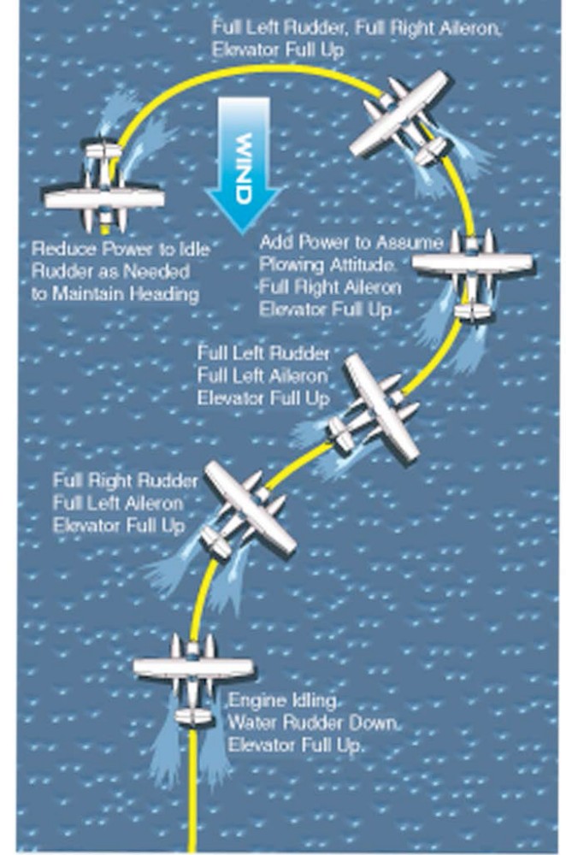

- What is a better method than a plowing turn for getting the airplane to the downwind side of the lake?
  - Sailing

- When do you use a sailing technique?
  - To get to the windward side of the shore or back into a tight spot.

- In what position are the rudders when power off sailing?
  - Up

- If you want to turn left when sailing, how are the control surfaces configured?
  - Left, Left, Right or Right, Right, Left
  - Turn, Yoke, Rudder Turn, Yoke, Rudder

Task F: Runway Incursion Avoidance (ASEL and ASES)

References: FAA-H-8083-3, FAA-H-8083-25; AC 91-73, AC 150-
5340-18; AIM.

Objective: To determine that the applicant exhibits knowledge of the elements of runway incursion avoidance by:

1. Exhibiting distinct challenges and requirements during taxi operations not found in other phases of flight operations.
2. Exhibiting procedures for appropriate cockpit activities during taxiing including taxi route planning, briefing the location of HOT SPOTS, communicating and coordinating with ATC.
3. Exhibiting procedures for steering, maneuvering, maintaining taxiway, runway position, and situational awareness.
4. Knowing the relevance/importance of hold lines.
5. Exhibiting procedures to ensure the pilot maintains strict focus to the movement of the aircraft and ATC communications, including the elimination of all distractive activities (i.e. Cell phone, texting, conversations with passengers) during aircraft taxi, takeoff and climb out to cruise altitude.
6. Utilizing procedures for holding the pilot’s workload to a minimum during taxi operations.
7. Utilizing taxi operation planning procedures, suchas recording taxi instructions, reading back taxi clearances, and reviewing taxi routes on the airport diagram.
8. Utilizing procedures to insure that clearance or instructions that are actually received are adhered to rather than the ones expected to be received.
9. Utilizing procedures to maintain/enhance situational awareness when conducting taxi operations in relation to other aircraft operations in the vicinity as well as to other vehicles moving on the airport.
10. Exhibiting procedures for briefing if a landing rollout to a taxiway exit will place the pilot in close proximity to another runway which can result in a runway incursion.
11. Conducting appropriate after landing/taxi procedures in the event the aircraft is on a taxiway that is between parallel runways.
12. Knowing specific procedures for operations at an airport with an operating air traffic control tower, with emphasis on
Communications and runway entry/crossing authorizations.
13. Utilizing ATC communications and pilot actions before takeoff, before landing, and after landing at towered and non-towered airports.
14. Knowing procedures unique to night operations.
15. Knowing operations at non-towered airports.
16. Knowing the use of aircraft exterior lighting.
17. Knowing the hazards of low visibility operations.

- Airport and Seaplane Base Operations

Task C: Airport/Seaplane Base, Runway, and Taxiway
Signs, Markings, and Lighting (ASEL and ASES)

References: FAA-H-8083-23, FAA-H-8083-25; AIM; AFD; AC 91-73, AC 150-5340-18.

Objective: To determine that the applicant:

1. Exhibits satisfactory knowledge of the elements related to airport/seaplane base, runway, and taxiway operations with emphasis on runway incursion avoidance.
2. Properly identifies and interprets airport/seaplane base, runway, and taxiway signs, markings, and lighting, with emphasis on runway incursion avoidance.

===========================================
- What is the significance of
  - Red buoys and Green buoys?
    - Red – keep bouy to right to follow primary channel coming from seaword
    - Green – keep bouy to right to follow primary channel TO seaword (open waters)
  - Orange buoys?
    - Danger

- Can you anchor between Red and Green buoys?
  - No. Navigation route.

- Docking
  - What things do you need to consider when docking?
    - Posts sticking up
    - Wind
    - Being able to “go around”
    - Is the bottom of the dock higher than the top of the float?
  - What are some ways to slow down when docking?
    - Turn off a mag
    - Put down flaps
    - Carb heat
    - Open the doors
    - Obviously head into the head when possible

- What things do you need to consider when beaching?
  - Sand, rocks, gravel, asphalt, concrete
  - Logs, stumps
  - Place to tie down safely

- What things do you need to consider when ramping?
  - The type of surface
  - If ramping on a wooden ramp, ensuring the floats stay ON the ramp

